Company X Data Department Report

To Enhance Customer Loyalty:

* What is the Most Used Ship mode by our customers?
* Who are out top 10 Customers in terms of sales?

To Monitor Our Strength and Weak Points:

* Which segment of clients generates the most sales?
* Which state generates the most sales Percentage/Contribution by Region?

Performance Measurements:

* What are the top performing product categories in terms of sales and profit?
* What is the most profitable product that we sell?

Customer Experience:

* On average how long does it take the orders to reach our clients?
  + - Based on each shipping mode

# Executive Summary

We exported the sales data from our database and we conducted some analysis to gain insights into some of our sales operations and study ways of enhancing our services based on a certain scope.

## Scope:

* Customer Loyalty
* Strength and Weak Points
* Performance
* Customer Experience

## Data Specs:

Here are the tables we used to conduct our analysis

* Orders Table
* Return Table
* Shipping Cost Table
* People Table

# The Analysis:

## Customer Loyalty

1. What is the Most Used Ship mode by our customers?

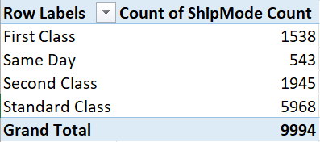

Based on the table above, the percentage distribution of shipping modes was calculated from the orders table, and we found that the Standard Class Shipping mode was the most one used by our customers by 5968.

Recommendation:

* We should focus more promotions on the standard shipping Mode as is it the most used.
* We recommend to find ways to reduce the cost of the standard shipping mode and make sure it’s profitable
* First Class shipping mode was the least used shipping mode which might be better to revise the cost and the possible scenarios where it might be removed

1. Who are out top 10 Customers in terms of sales?

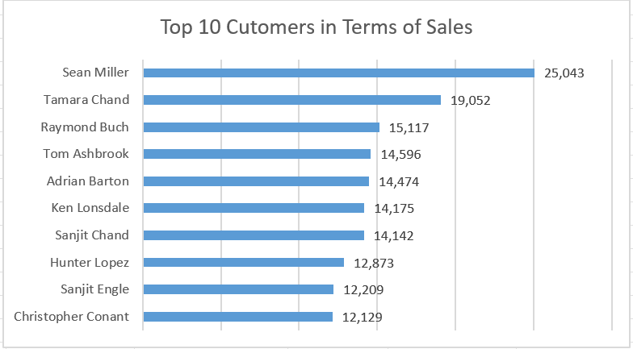

Recommendation:

* Develop targeted marketing campaigns and personalized offers for the top-spending customers (e.g., Sean Miller, Tamara Chand). By nurturing these relationships, you can increase customer loyalty and potentially grow their spending even further.
* Analyze demographic, behavioral, or regional data for these top 10 customers to find patterns. Understanding what they have in common such as product preferences or purchase frequency can help you replicate their success across a broader customer base.
* Encourage repeat business and leverage word-of-mouth marketing by creating an exclusive loyalty program for high-value customers. Offer incentives or discounts for referrals, which can attract new customers and strengthen existing relationships.

## Strength and Weak Points:

1. Which segment of clients generates the most sales?

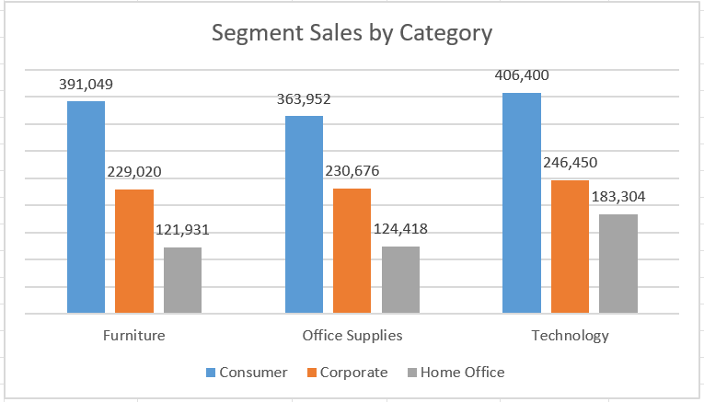

Based on the clustered column above, the Technology Category and the Consumer Segment generated the most Sales

Recommendation:

* Promote Technology Products to Consumers: Given high Consumer sales in Technology, launch targeted marketing campaigns to maintain momentum and drive repeat purchases.
* Upsell Furniture to Corporate Clients: Corporate sales for Furniture are strong; consider bundled deals or customized solutions to further boost revenue.
* Expand Home Office Segment: Develop specialized promotions for the growing Home Office market, especially in Office Supplies and Technology, to capture additional share.
* Use data from high-performing categories (like Technology for Consumers) to cross-sell related products from Office Supplies or Furniture. For example, offer a discount on a home office chair when purchasing a laptop.
* Analyze purchase histories of mid-tier customers (such as Lisa Ryan and Tanja Norvell) to recommend complementary products or services. Tailored offers can boost average transaction value and overall satisfaction.
* For lower-volume customers (e.g., Bryan Spruell), create personalized outreach campaigns—like special discounts or new product highlights—to re-engage them and encourage additional sales.

1. Which state generates the most sales Percentage/Contribution by Region?

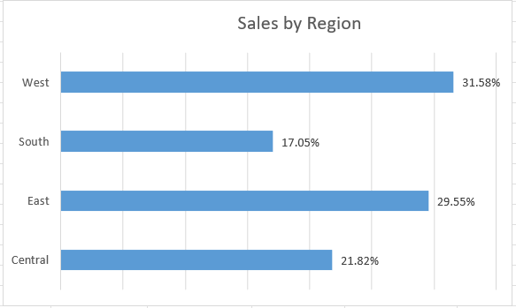

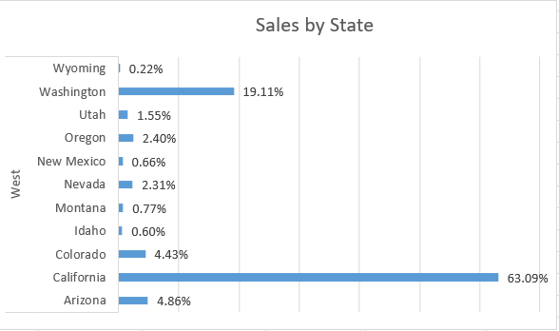

Based on the two clustered bars above, California in the West Region has the most sales contribution by 63.09%

Recommendation:

* Continue investing in top-performing regions (like California) by running targeted marketing campaigns and expanding product availability to capitalize on existing momentum.
* Develop customized promotions for states like Utah and Idaho to address local needs, and increase market share.
* Ensure robust inventory and faster delivery in mid‑tier West markets—Colorado (4.43%), Arizona (4.86%) and Oregon (2.40%)—by partnering with local distributors or opening micro‑fulfillment centers.
* Use programmatic ads and social media geo‑fencing to drive awareness in the South (17.05%) and Central (21.82%) regions, tailoring creative to local events and cultural touchpoints
* Create limited‑time offers or “state specials” in very low‑share markets (e.g., Wyoming, New Mexico, Idaho) to stimulate trial, gather market feedback, and build early traction.
* Establish or reconfigure regional hubs in Central and South zones to cut shipping times and costs—this improves service levels, supports promotional activities, and strengthens competitive positioning

5. What are the top performing product categories in terms of sales and profit?

Based on the stacked column above, Technology is the top performing product

Recommendation:

* Maintain strong Furniture sales, improve profitability: High sales volume needs continued focus with exploration of higher profit margins.
* Analyze low Office Supplies profitability: Low profit compared to sales requires a detailed study of costs and pricing.
* Leverage high Technology profitability: Understand the reasons for strong profit in Technology and explore sales growth potential.

1. What is the most profitable product that we sell?

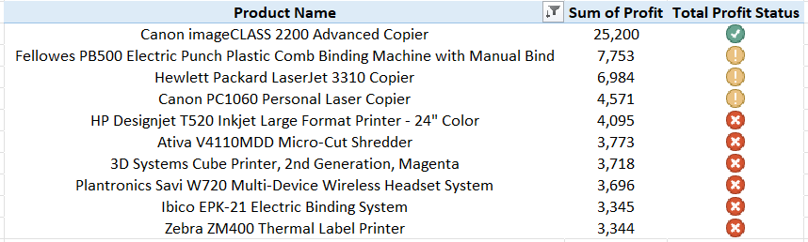

According to this table above, “Canon imageCLASS 2200 Advanced Copier” is the most profitable product that we sell by 25,200$

Recommendation:

* Boost Canon imageCLASS 2200 sales**:** Capitalize on its high profit with targeted marketing and inventory management.
* Analyze low-profit products: Investigate "!" and "X" status items to identify reasons for underperformance and potential improvements or discontinuation
* Reduce reliance on one product: Diversify profitable offerings and explore new opportunities to mitigate risks.
* Optimize pricing for all products**:** Review and adjust pricing strategies across the board to improve profit margins.

1. On average how long does it take the orders to reach our clients? Based on each shipping mode.

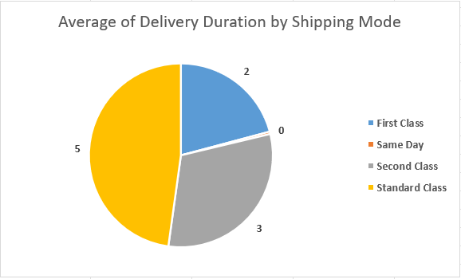

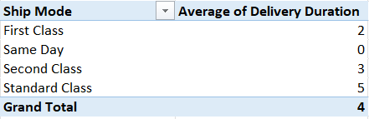

Recommendation:

* Prioritize "Same Day" shipping: With an average delivery duration of 0 days, it's the most efficient. Market and leverage this option for urgent deliveries to enhance customer satisfaction.
* Investigate "Standard Class" delays: The 5-day average is the longest. Analyze the reasons for this extended duration and explore ways to reduce it to improve overall delivery times.
* Promote "First Class" & "Second Class": Their shorter delivery times (2 & 3 days) offer a good balance between speed and potentially cost. Position them as reliable alternatives to "Standard Class."
* Analyze shipping mode costs: Compare the cost associated with each shipping mode against their average delivery duration to optimize for both speed and expense efficiency.